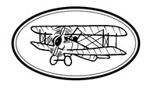

I am going into year 2

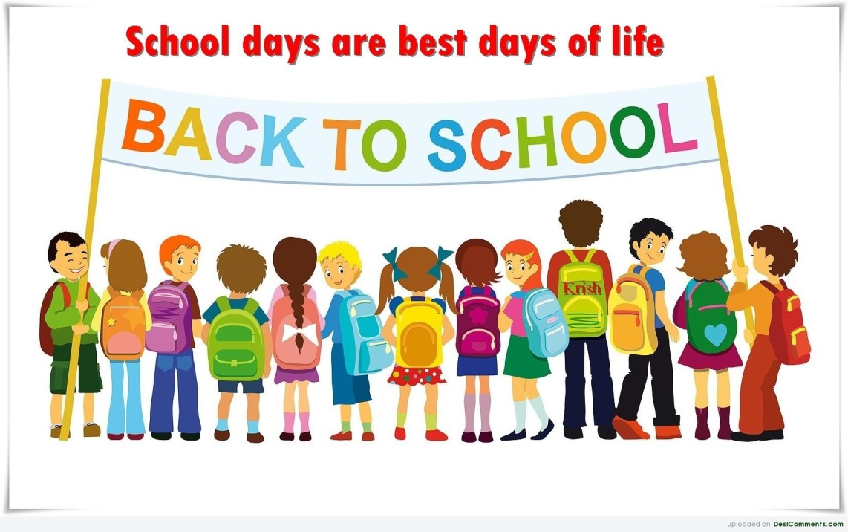

I am going into year 2
Some things will be the same in September these are:
- School will still be fun.
- I will see lots of grown -ups that I already know.
- I can still see and play with my friends in my class and I will make new friends too.
- I will still have a playtime in the morning.
- I will have assembly in my class every week.
- I will have fun learning in my new class.

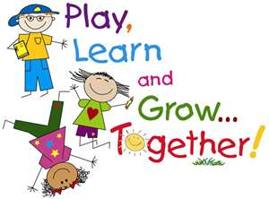

Things that will change in September are:
- I will have a new teacher, but it’s ok because I have met them before.
- I will have a new classroom.
- The work will be a little different but my teachers are there to help me if I need it.
- I don’t need to worry because all my friends are having the same change.
- We won’t have assemblies straight away but things could change later in the year.
- I will eat lunch in my classroom but this could change later in the year.
- My drop- off and pick time might be different from other classes in the school.
- I will be in year 2!

Here is the year 2 team
Magpie Class
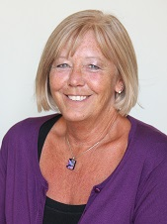
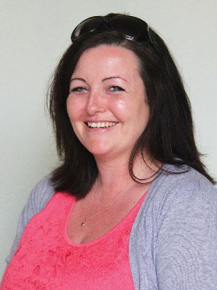
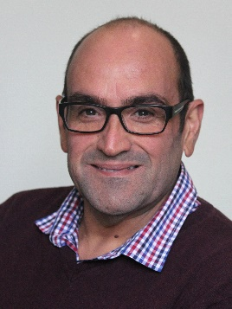
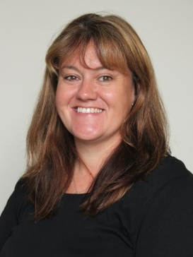
Mr Price
PPA Cover

Mrs Keen
Mrs Cripps
Mrs Poate

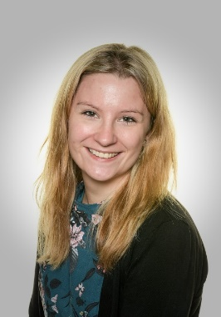
Owls Class
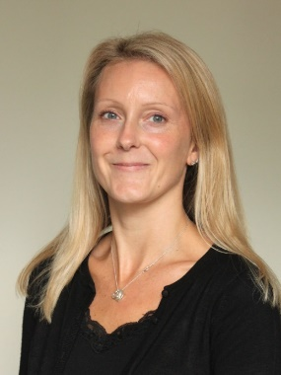
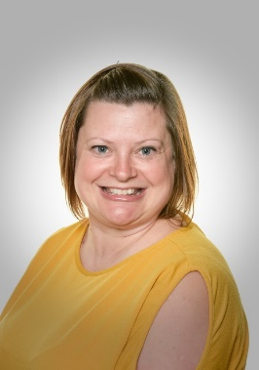
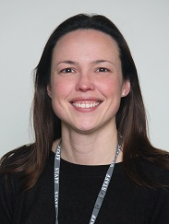

Mrs Roberts
PPA Cover
Miss Davis
Miss Myers
Mrs Munt

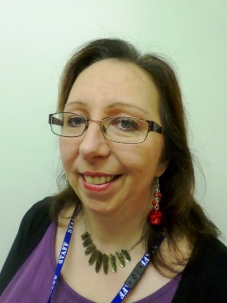
Blackbird Class
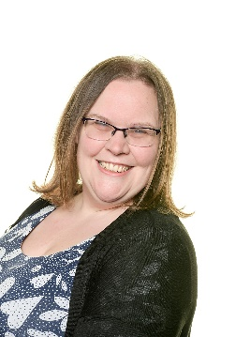
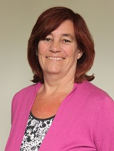
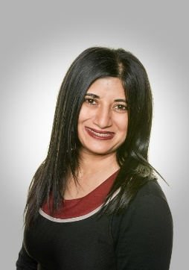
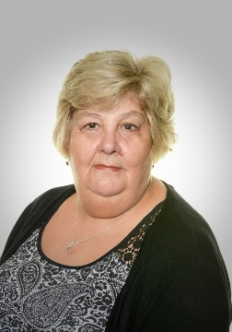
Mrs Sayer
PPA Cover

Mrs Cave
Friday afternoons
Mrs Graham
Mrs Feilder

Mrs Johnston

Key stage 1 ELSAs
Mrs Kennell and Mrs Roberts will be able to help you too!
We will be on the playground in the mornings to greet you with a smile. Don’t forget to say hello!
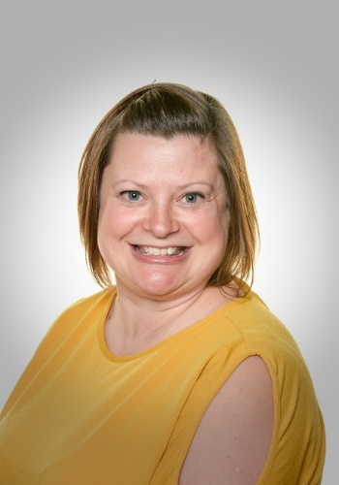
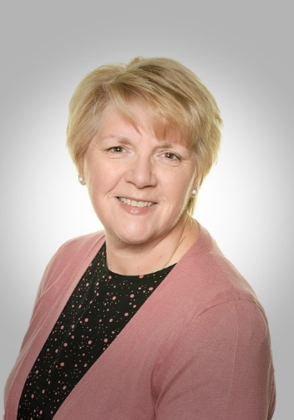
Mrs Roberts
Mrs Kennell

Here are some pictures of the classrooms, so you know where to stand in the mornings.
This is where you will come into the Blackbirds

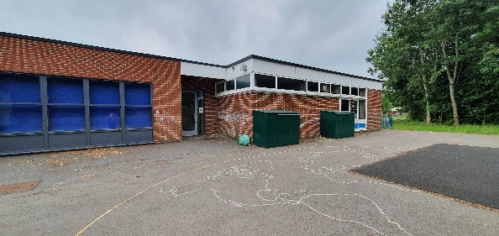

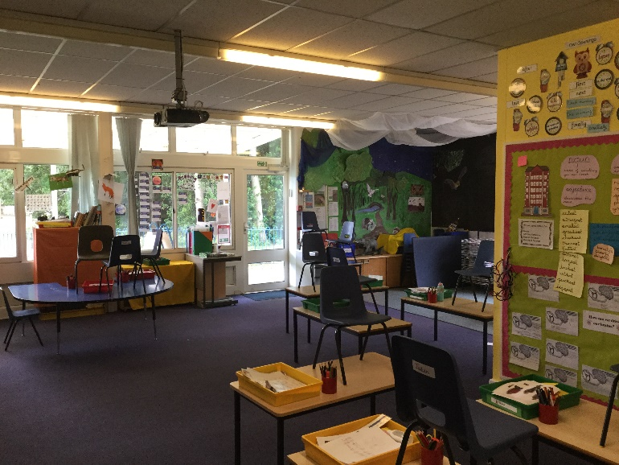
This is the Blackbirds classroom at the moment. It is set up for a much smaller bubble so will look a bit different when you start in September
This is where you will come in to the Owls.
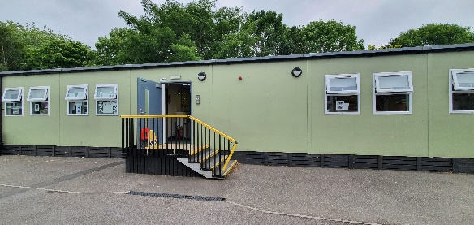

This is the Owls classroom at the moment. It is set up for a much smaller bubble so will look a bit different when you start in September.
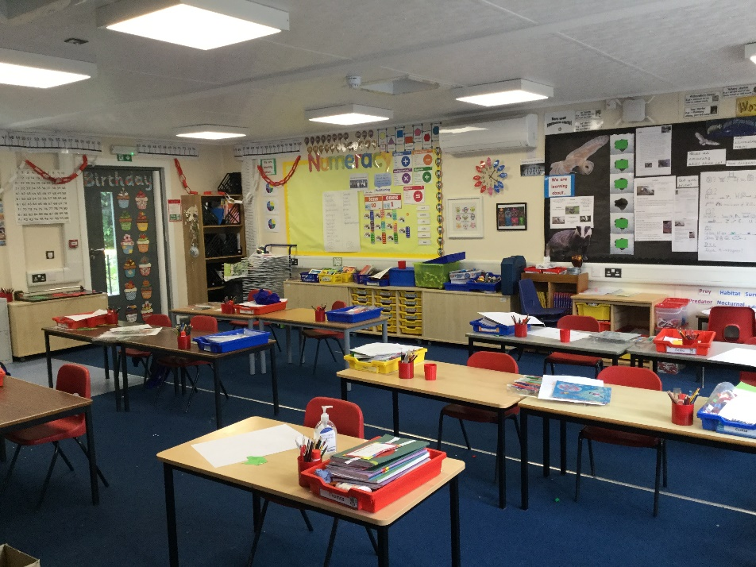

This is where you will come in to the Magpies.
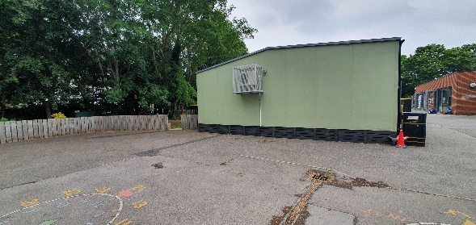

This is the Magpies classroom at the moment. It is set up for a much smaller bubble so will look a bit different when you start in September.
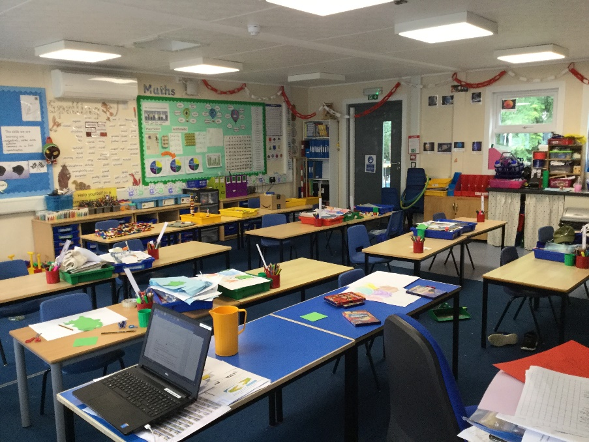

We look forward to seeing you in your new classrooms with your new teachers very soon!
Have a lovely summer break and stay safe and well.
From Mrs Roberts and the Year 2 Team

