This is a great game to play online to teach blending in a fun way! The children need to put the ‘real’ words into the treasure and the ‘fake’ words into the bin!
https://www.phonicsplay.co.uk/resources/phase/2/buried-treasure
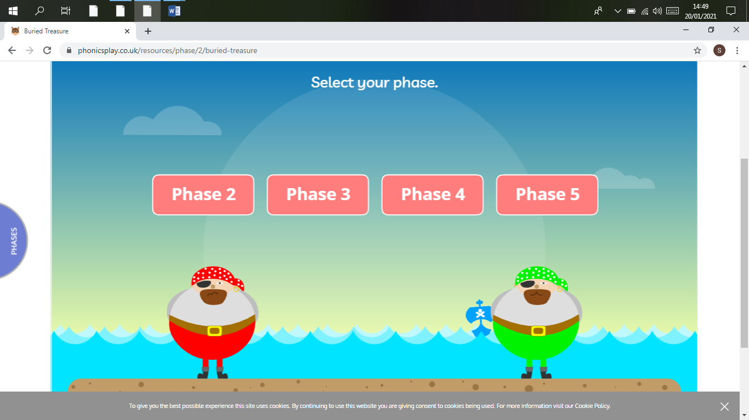
We are only on phase 2 so please do not go any higher

