Year R maths. Wednesday 20th January
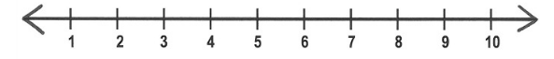
One more and one less using a number line
Use your finger to jump along the number line to find one more and one less.

One less | 7 | One more

9

4

6

12
